Project Development Phase
Performance Test

Date | 02 October, 2026
Team ID | SWTID-2026-3664
Project Name | Script-Controlled ACL – Restrict Record Access Based on Field Value
Maximum Marks

Model Performance Testing:
Project team shall fill the following information in model performance testing template.
S.No. | Parameter | Screenshot / Values
 | Records Displayed | 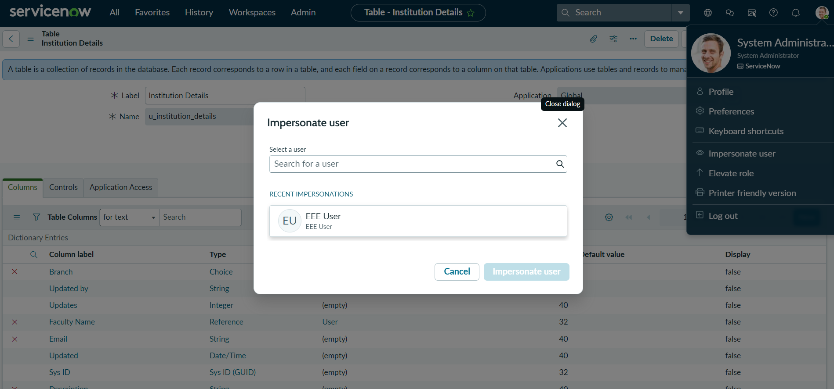
 | Access Validation | User role and record field value are checked before granting access.
3. | Utilization of ACL Conditions | 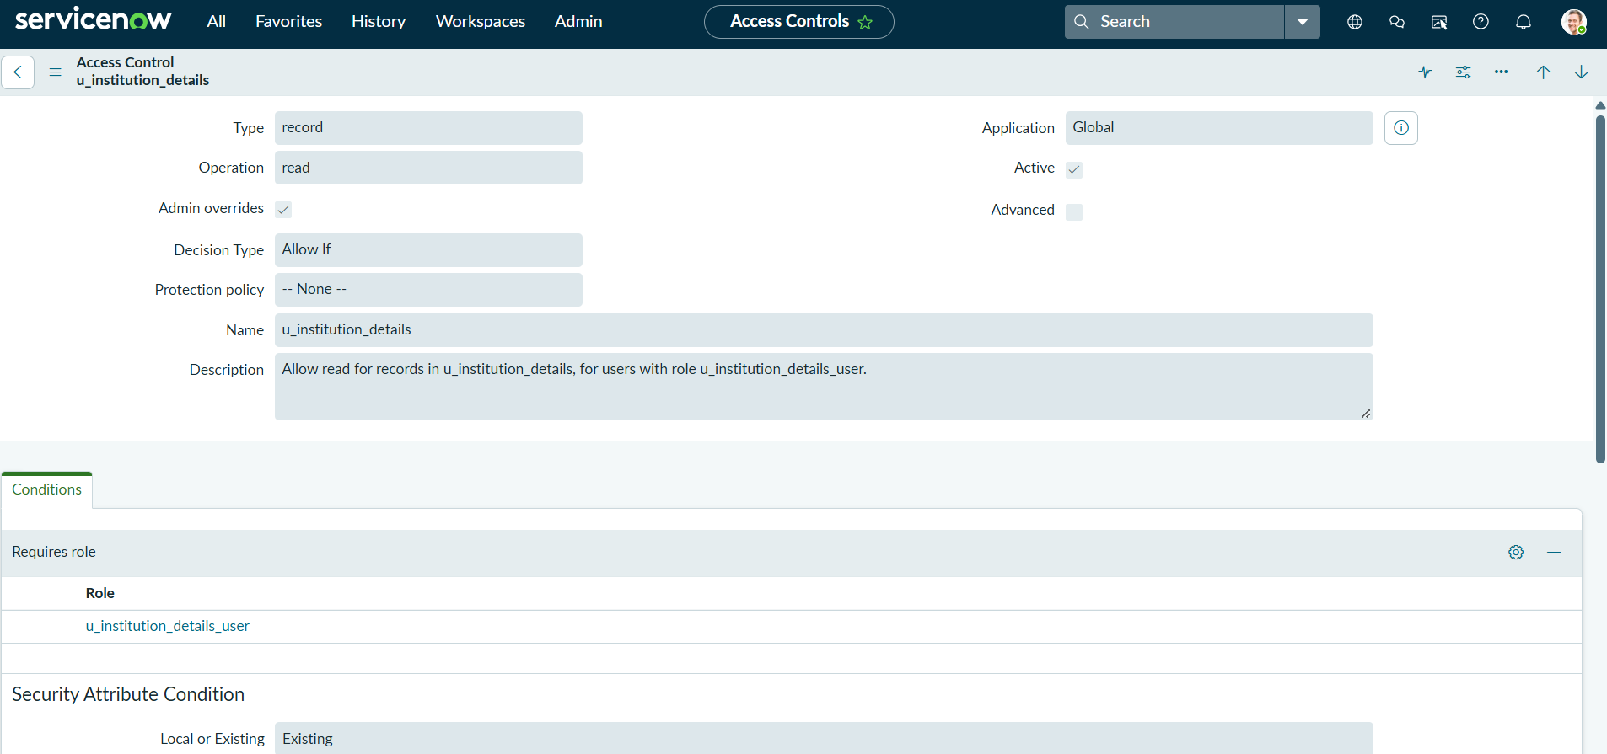
4. | Access Rules Used | 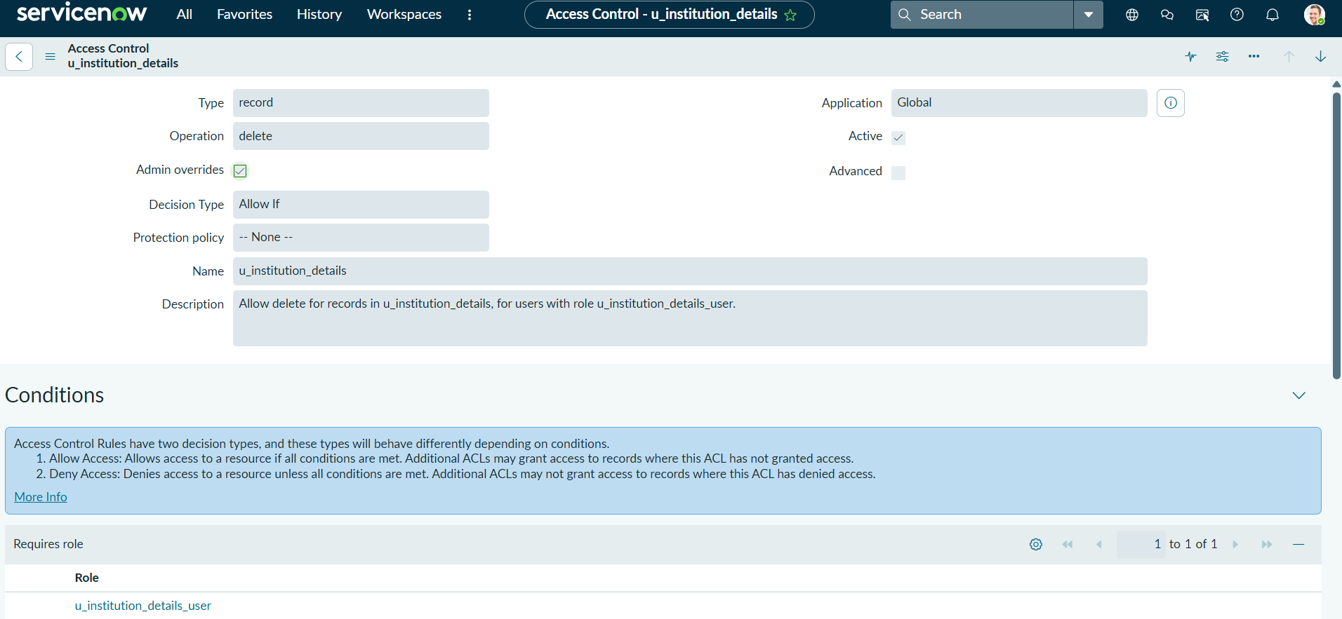
5. | Security Design | No. of ACL operations: 4 — READ, CREATE, WRITE and DELETE.
6 | Access Control Design | Centralized script-controlled access to protect sensitive records and prevent unauthorized actions.

